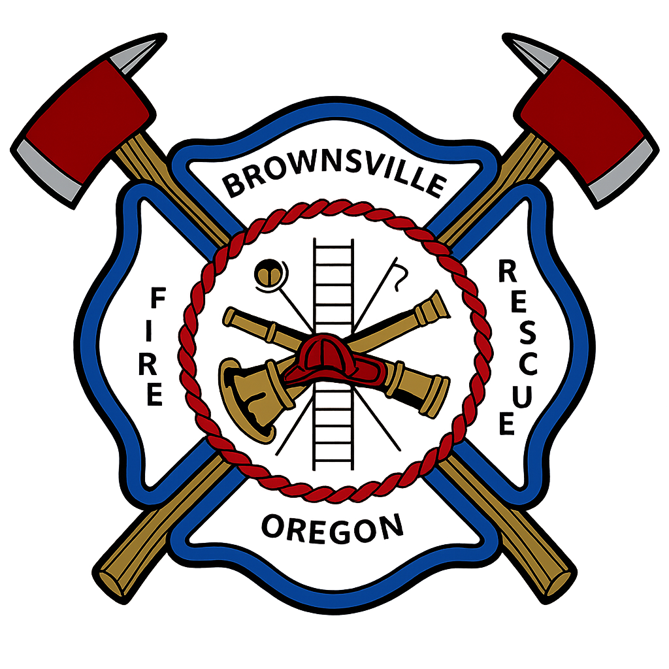

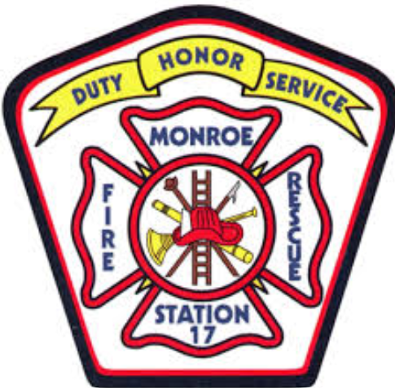
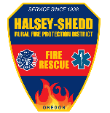
Spring NFPA Firefighter I Academy
April/May
2026
Welcome to the Lebanon, Brownsville, Monroe and Halsey-Shedd volunteer fire academy. The academy will run from April through the end of May. The class will cover all the job performance requirements for the NFPA Firefighter I.
Absences: Attendance is very important and multiple absences well disqualify you from continuing in the Academy. Please contact your home agency if you are unable to attend an academy day. Please show up on time, it is recommended to arrive 15 minutes early.
Book: IFSTA Essentials of Firefighting 7th Edition
IFSTA Student Workbook 7th Edition

Attire: Exercise clothes are the preferred attire for the academy.
Training Locations:
Halsey-Shedd RFPD Brownsville RFPD
Station 51 Station 61
740 W 2nd St. 600 E Blakely Ave
Halsey, OR 97348 Brownsville, Or 97327

Lebanon Fire District
Station 31
1050 W. Oak St.
Lebanon, OR 97355

April 11th 2026 Day 1
Location: Lebanon Fire District Station 31
Time | Teaching Topic | Instructor | Notes
0800 | SCBA Review & Donning | DC Russell Duerr | Classroom – IFSTA Book  60 Second Proficiencies  SCBA Confidence Drill
1100 | Communications | DC Russell Duerr | Radio Review  -Handheld HOT  -Mobile Radio HOT
 | Lunch
1300 | Health and Safety | DC Russell Duerr | -Cancer Awareness  -Air Monitoring  -Traffic Safety  Reilly Breathing Technique
1645 | Wrap-Up |  | Restore SCBA Equipment

April 15th 2026 Day 2
Location: Halsey Shedd Fire Station 51
Time | Teaching Topic | Instructor | Notes
1800 | Fire Behavior | DC. Duerr | HSFD Training  Classroom
1900 | Mini-House Burn/ Burn Room | DC Fitzwater | Training Ground
2000 | Extinguishers | DFM Adamson | Classroom/Hands-On
2100 | Wrap-up |  | Restore Equipment/ Wrap-up

April 18th 2026 Day 3
Location: Lebanon Fire Station 31
Time | Teaching Topic | Instructor | Notes
0800 | Search & Rescue Classroom | Lt. Michael Perkins | Station 31
0930 | Search & Rescue HOT | Lt Michael Perkins | Training Tower
1200 | Lunch
1300 | Search & Rescue HOT | Lt. Michael Perkins | Training Tower
1645 | Wrap-up |  | Restore Equipment

April 22nd 2026 Day 4
Location: Lebanon Fire Station 31
Time | Teaching Topic | Instructor | Notes
1800 | RIC Training Classroom | Lt. Michael Perkins | Classroom
2000 | RIC HOT | Lt. Michael Perkins | Training Tower
2130 | Wrap-up |  | PIA – Classroom

April 25th 2026 Day 5
Location: Lebanon Fire Station 31
Time | Teaching Topic | Instructor | Notes
0800 | Ground Ladders | FF. Corey Knipstien | Station 31  Classroom
0900 | Ground Ladders | FF. Corey Knipstien | 24ft Extension  24ft Extension with Roof Ladder  35ft Extension  Attic Ladder
1200 | Lunch
1300 | Ground Ladders | DC Russell Duerr | Ladder Bail-out Drill  Victim Removal
1700 | Wrap-up |  | Restore Equipment

April 29th 2026 Day 6
Location: Lebanon Fire Station 31
Time | Teaching Topic | Instructor | Notes
1800 | Forcible Entry | FF Juan Garcia | Station 31 Classroom
1900 | Forcible Entry | FF Juan Garcia  FF Connor Fitzgerald | Station 31 LFD Training Grounds  -Inward, Outward Doors  -Cutting Bars / Chain  -Forcing Window
2130 | Wrap-up |  | Restore Equipment

May 2nd 2026 Day 7
Location: Lebanon Fire Station 31
Time | Teaching Topic | Instructor | Notes
0800 | Intro to Chainsaws | ENG. Ben Walton | Station 31  Classroom
1000 | Ventilation  - Vertical  - Horizontal  - Hydraulic | DC. Russell Duerr | Classroom
1200 | Lunch
1300 | Ventilation  - Vertical  - Horizontal  - Hydraulic | DC. Russell Duerr | Hands-on
 | Chain Saw Maintenance | DC. Russell Duerr | Hands-on
1630 | Wrap-up |  | Restore Equipment

May 6th 2026 Day 8
Location: Lebanon Fire Station 31
1800 | Building Construction | Lt. Greg Chaffin | Station 31  Classroom
2000 | Utilities | Lt. Greg Chaffin | Classroom
2130 | Wrap-up |  | Debrief

May 9th 2026 Day 11
Location: Lebanon Fire District Station 31
Time | Teaching Topic | Instructor | Notes
0800 | Nozzle Forward | Lt. Cody Manzi | Classroom
0900 | Nozzle Forward | Lt. Cody Manzi | Training Grounds
1200 | Lunch
1300 | Nozzle Forward | Lt. Cody Manzi | Training Grounds
1645 | Wrap-up |  | Restore Equipment

May 13th 2026 Day 10
Location: Lebanon Fire Station 31
Time | Teaching Topic | Instructor | Notes
1800 | Hose Deployment | Lt. Cody Manzi | Preconnected lines:  1 ¾ Cross lays “Minuteman”
2000 | Hose Deployment | Lt. Cody Manzi | 1 ¾ Bumper Load” Scorpion Load”  2 ½ Minuteman
2200 | Wrap-up |  | Restore Equipment

May 16th 2026 Day 9
Location: Brownsville Station 61
Time | Teaching Topic | Instructor | Notes
0800 | Water Supply | Lt. Wiebe | Classroom/ Training Grounds
0900 | Fire Hose | Lt. Wiebe | Training Grounds  -Taking a Hydrant Wet/Dry
1200 | Lunch
1300 | Fire Hose | Lt. Wiebe | Master Stream Operations  -Deck Gun  -Ground Monitor  -Blitz Fire
1645 | Wrap-up |  | Restore Equipment

May 17th 2026 Day 12
Location: Lebanon Fire Station 31
Time | Teaching Topic | Instructor | Notes
0800 | Loss Control Classroom | DC. Russell Duerr | Station 31 Classroom
0900 | Loss Control HOT | DC Russell Duerr | HOT
1200 | Lunch
1300 | Ropes and Knots (Knot Review) | Lt. Jason Carroll | Station 31 Classroom
1400 | Hoisting Tools |  | Training Tower

May 20th 2026 Day 13
Location: Lebanon Fire Station 31
Time | Teaching Topic | Instructor | Notes
1800 | Hose Deployment | DC Russell Duerr | Preconnected lines:  1 ¾ Cross lays “Minuteman”
2000 | Hose Deployment | DC Russell Duerr | 1 ¾ Bumper Load” Scorpion Load”  2 ½ Minuteman
2200 | Wrap-up |  | Restore Equipment

May 27th 2026 Day 14
Location: Lebanon Fire Station 31
Time | Teaching Topic | Instructor | Notes
1800 | House Fire Evolutions | DC Russell Duerr | Station 31 Training Grounds
2130 | Wrap-up

May 28th 2026 Day 15
Location: Lebanon Fire Station 31
Time | Teaching Topic | Instructor | Notes
1900 | Car Fire Training | DC Russell Duerr | Classroom
2000 | Vehicle Fire | DC Russell Duerr | Training Grounds (Car Fire Prop)

May 30th 2026 Day 16 (Final Day)
Location: Halsey Shedd Fire Station 51
Time | Teaching Topic | Instructor | Notes
0900 | Pre-Burn Briefing | DC Russell Duerr | Station 51
1000 | Live Fire Exercise | DC Russell Duerr | Fixed Facility  HOT
1200 | Debriefing |  | Classroom

